# [**Fall 2020 TV Schedule: Your Full List of Network Premiere Dates**](https://www.tvinsider.com/947791/fall-tv-schedule-2020-premiere-dates/amp/?__twitter_impression=true&s=09)

U,{fe51e850-dd78-4bad-a88b-754bdd525eb4}{60},3.125,3.125 [Meredith Jacobs](https://www.tvinsider.com/author/meredith-jacobs/)

3 days ago

F,{fe51e850-dd78-4bad-a88b-754bdd525eb4}{82},3.125,3.125

Return dates for many of our favorite shows are still up in the air, but networks have promised that there’s still new content coming to TV this fall.

The highly-anticipated Season 16 of [*The Bachelorette*](https://www.tvinsider.com/show/the-bachelorette/) with [Clare Crawley](https://www.tvinsider.com/people/clare-crawley/) is already scheduled, as are ABC’s Wednesday comedies. The CW is saying goodbye to [*Supernatural*](https://www.tvinsider.com/show/supernatural/) after 15 seasons with the final seven episodes. NBC has scheduled its popular comedies (like [*Superstore*](https://www.tvinsider.com/show/superstore/)) and dramas ([*This Is Us*](https://www.tvinsider.com/show/this-is-us/) and [*Law & Order: SVU*](https://www.tvinsider.com/show/law-order-svu/)) for November. And game show enthusiasts will have plenty to watch with [*Who Wants to Be a Millionaire*](https://www.tvinsider.com/show/who-wants-to-be-a-millionaire/) and [*Supermarket Sweep*](https://www.tvinsider.com/show/supermarket-sweep/).

Check out a full list of the fall premiere dates below.

## **SUNDAY**

**September 20**

7:00 p.m.: *60 Minutes* (CBS)

**September 27**

8:00 p.m.: *The Simpsons* (Fox)

8:30 p.m.: *Bless the Harts* (Fox)

9:00 p.m.: *Bob’s Burgers* (Fox)

9:30 p.m.: *Family Guy* (Fox)

F,{fe51e850-dd78-4bad-a88b-754bdd525eb4}{195},3.125,3.125U,{fe51e850-dd78-4bad-a88b-754bdd525eb4}{196},3.125,3.125

*Card Sharks* (ABC/Eric McCandless)

**October 18**

7:00 p.m.: *America’s Funniest Home Videos* (ABC)

8:00 p.m.: *Supermarket Sweep* (ABC)

9:00 p.m.: *Who Wants To Be A Millionaire* (ABC)

10:00 p.m.: *Card Sharks* (ABC)

## **MONDAY**

**September 7**

8:00 p.m.: *American Ninja Warrior* (NBC)

**September 14**

8:00 p.m.: *Dancing with the Stars* (ABC)

F,{4082443c-af65-4118-99a1-ead1c611658b}{35},3.125,3.125U,{4082443c-af65-4118-99a1-ead1c611658b}{36},3.125,3.125[**SEE ALSO**](https://www.tvinsider.com/gallery/dancing-with-the-stars-season-29-cast-dwts-carole-baskin-nelly-kaitlyn-bristowe/)

### [Meet the ‘DWTS’ Season 29 Cast: Carole Baskin, Nelly, Justina Machado & More](https://www.tvinsider.com/gallery/dancing-with-the-stars-season-29-cast-dwts-carole-baskin-nelly-kaitlyn-bristowe/)

Plus, ‘Selling Sunset’s Chrishell Stause, actors Anne Heche and Jesse Metcalfe, and more.

**September 21**

9:00 p.m.: *Filthy Rich* (Fox)

**October 19**

8:00 p.m.: *The Voice* (NBC)

**November 2**

10:00 p.m.: *The Good Doctor* (ABC)

## **TUESDAY**

**September 29**

8:00 p.m.: *The Weakest Link* (NBC)

**October 6**

9:00 p.m.: *Ellen’s Game of Games* (NBC)

9:00 p.m.: *neXt* (Fox)

F,{4082443c-af65-4118-99a1-ead1c611658b}{175},3.125,3.125

*neXt* (Ed Araquel / FOX)

**October 13**

8:00 p.m.: *The Bachelorette* (ABC)

10:00 p.m.: *The FBI Declassified* (CBS)

**October 20**

8:00 p.m.: *The Voice* (NBC)

**November 10**

9:00 p.m.: *This Is Us* (NBC)

**November 17**

10:00 p.m.: *Big Sky* (ABC)

## **WEDNESDAY**

**September 23**

8:00 p.m.: *The Masked Singer* (Fox)

9:00 p.m.: *I Can See Your Voice* (Fox)

F,{024f627f-5c7a-48cf-b494-5691d6af52db}{33},3.125,3.125[**SEE ALSO**](https://www.tvinsider.com/946823/the-masked-singer-season-4-costumes-premiere-date/)

### [‘The Masked Singer’ Season 4 Premiere Date & Costumes Revealed (VIDEO)](https://www.tvinsider.com/946823/the-masked-singer-season-4-costumes-premiere-date/)

Fox has also fast-tracked the all-new music guessing game series ‘I Can See Your Voice.’

**October 14**

9:00 p.m.: *The Amazing Race* (CBS)

**October 21**

8:00 p.m.: *The Goldbergs* (ABC)

9:00 p.m.: *The Conners* (ABC)

9:30 p.m.: *black-ish* (ABC)

**October 28**

8:30 p.m.: *American Housewife* (ABC)

**November 11**

8:00 p.m.: *Chicago Med* (NBC)

9:00 p.m.: *Chicago Fire* (NBC)

10:00 p.m.: *Chicago P.D.* (NBC)

**November 18**

10:00 p.m.: *For Life* (ABC)

## **THURSDAY**

**September 24**

8:00 p.m.: *Celebrity Family Feud* (ABC)

9:00 p.m.: *Press Your Luck* (ABC)

10:00 p.m.: *Match Game* (ABC)

**October 1**

8:30 p.m.: *Connecting* (NBC)

F,{024f627f-5c7a-48cf-b494-5691d6af52db}{219},3.125,3.125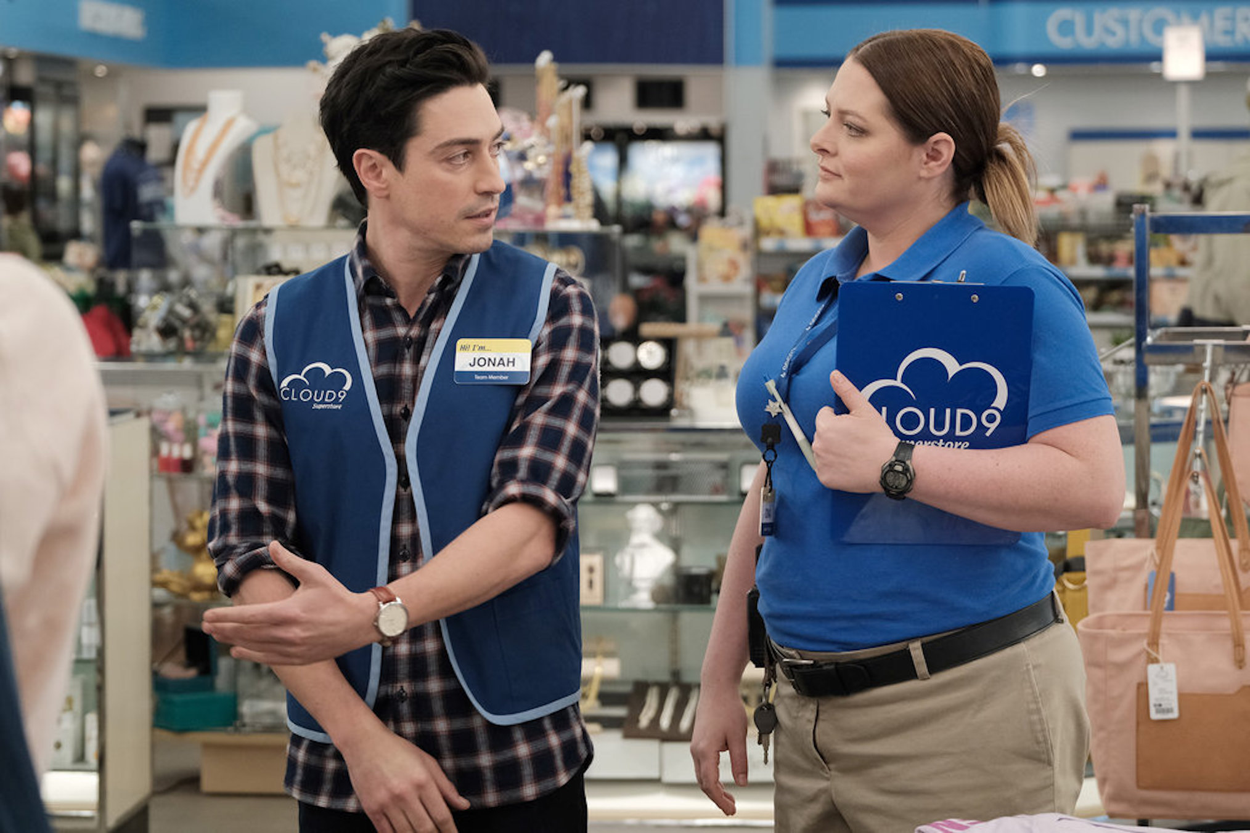

*Superstore* (Eddy Chen/NBC)

**October 8**

8:00 p.m.: *Supernatural* (The CW)

**October 22**

8:00 p.m.: *Superstore* (NBC)

**November 12**

8:00 p.m.: *Station 19* (ABC)

9:00 p.m.: *Grey’s Anatomy* (ABC)

9:00 p.m.: *Law & Order: SVU* (NBC)

**November 19**

10:00 p.m.: *A Million Little Things* (ABC)

## **FRIDAY**

**September 25**

10 p.m.: *Dateline NBC* (NBC)

**October 2**

9:00 p.m.: *Undercover Boss* (CBS)

**October 16**

8:00 p.m.: *Shark Tank* (ABC)

F,{07477bd0-daa4-42c3-9b60-fd97b4572ae0}{105},3.125,3.125[**SEE ALSO**](https://www.tvinsider.com/946874/nbc-premiere-dates-2020-one-chicago-svu-organized-crime/)

### [One Chicago & ‘SVU’ Get Fall Premiere Dates—What About ‘Organized Crime’?](https://www.tvinsider.com/946874/nbc-premiere-dates-2020-one-chicago-svu-organized-crime/)

Episodes of Dick Wolf’s shows will be available on Peacock.

**November 13**

8:00 p.m.: *The Blacklist* (NBC)

## **SATURDAY**

**September 12**

10:00 p.m.: *48 Hours* (CBS)

**October 3**

11:30 p.m.: *Saturday Night Live* (NBC)

## **STILL TO BE SCHEDULED IN 2020**

**CBS**

*The Neighborhood*, *Bob Hearts Abishola*, *All Rise*, *Bull*, *NCIS*, *FBI*, *FBI: Most Wanted*, *SEAL Team*, *S.W.A.T.*, *Young Sheldon*, *B Positive*, *Mom*, *The Unicorn*, *Evil*, *MacGyver*, *Magnum P.I.*, *Blue Bloods*, *The Equalizer*, *NCIS: Los Angeles*, *NCIS: New Orleans*